Circuit Analysis (Lab 7)
Experiment 7: Analysis of Operational Amplifiers Operations

Name: Sagheer Hussain Registration No: 2025-CE-109

Date: 04-May-2026 Grade and Signature: …………………

CLO4 | Construct amplifiers with operational amplifiers.
Psychomotor/ Affective | Level1  (1) | Level2  (2-3) | Level3  (4-5) | Level4  (6-7)
Report Marks (3) |  |  | Total marks (10)

Objective
The objective of this lab is to investigate the input to output relationship for inverting and non- inverting amplifiers.

Apparatus Required

Sr. No. | Apparatus | Range | Quantity
1 | Regulated Power Supply | Standard | 1
2 | Signal Generator | Standard | 1
3 | Oscilloscope | Standard | 1
4 | Digital Multimeter | Standard | 1
5 | Breadboard & Wires | Standard | As Required
6 | Resistors | 1k Ω, 2k Ω ,3k Ω | 3
Description
Operational amplifiers can be used in two basic configurations to create amplifier circuits. One is the inverting amplifier where the output is the inverse or 180° out of phase with the input, and the other is the non-inverting amplifier where the output is in the same sense or in phase with the input.
Both operational amplifier circuits are widely used and they find applications in different areas. When an operational amplifier or op-amp is used as a non-inverting amplifier it only requires a few additional components to create a working amplifier circuit.
Pin configuration of IC 741 op amp is shown below

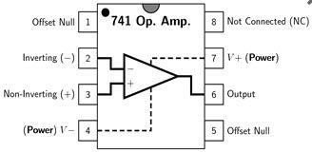
- Pin 1 is offset null.
- Pin 2 is inverting input terminal.
- Pin 3 is a non-inverting input terminal.
- Pin 4 is negative voltage supply (VCC)
- Pin 5 is offset null.
- Pin 6 is the output voltage.
- Pin 7 is positive voltage supply (+VCC)
- Pin 8 has no connection.

Precautions:
- Voltage control knob should be kept at minimum position.
- Current control knob of RPS should be kept at maximum position.
- Carefully utilize the oscilloscope channels and function generator.

Procedure for Inverting Amplifier:
- Wire up the circuit as shown in the figure below on the breadboard.
- Give the input to the inverting terminal of the op-amp and simultaneously display the input and output on the oscilloscope.
- Draw the input & output waveforms at the end of the lab.
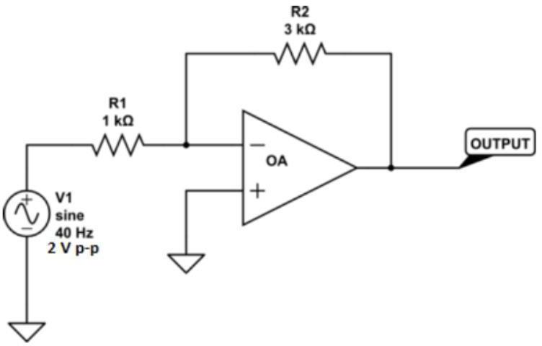

Procedure for Non-Inverting Amplifier:
- Wire up the circuit as shown in the figure below on the breadboard.
- Give the input to the non-inverting terminal of the op-amp and simultaneously display the input and output on the oscilloscope.
- Draw the input & output waveform at the end of the lab.

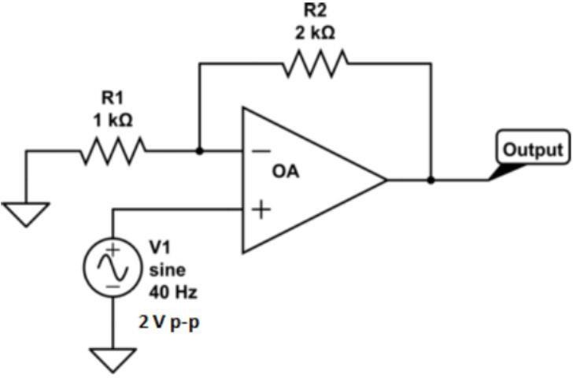



Result:
0V

3V

1V

0V

2V

Figure 7: Input Voltage Signal Figure 8: Inverted Output
-3V

-2V

-1V


1V

3V

0V

2V

Figure 9: Non-Inverting Output

Post Lab Questions

Define Inverting Amplifier

An inverting amplifier is an operational amplifier (Op-Amp) configuration in which the input signal is applied to the negative (−) terminal. Its main function is to amplify the input signal while producing an output that is 180° out of phase. This means that when the input signal increases, the output decreases, and vice versa.

Define Non-Inverting Amplifier

A non-inverting amplifier is an Op-Amp circuit where the input signal is applied to the positive (+) terminal. It amplifies the input signal without changing its phase. As a result, the output signal remains in phase with the input, meaning both increase and decrease together.

What are the applications of inverting amplifiers?

Summing Amplifiers: Used to combine multiple input signals into a single output.

Phase Shifters: Applied in communication systems where a 180° phase shift is required.

Integration/Differentiation Circuits: Used in analog signal processing to perform mathematical operations like integration and differentiation.

What are the applications of non-inverting amplifiers?

Voltage Buffers: Provide isolation between circuit stages due to high input impedance.

Signal Conditioning: Amplify weak signals (e.g., from sensors) without altering their phase.

Audio Preamplifiers: Boost low-level audio signals while preserving signal quality and clarity.

What is the gain of an amplifier?

Gain is a ratio that indicates how much an amplifier increases the magnitude of an input signal. It is calculated as the ratio of output to input (voltage, current, or power). Gain shows how many times the input signal has been amplified.

How do you calculate the gains for inverting and non-inverting amplifiers?

The voltage gain (Av) depends on the feedback resistor (Rf) and the input resistor (Rin):

Inverting Amplifier Gain:

Av = −Rf / Rin

(The negative sign indicates phase inversion.)

Non-Inverting Amplifier Gain:

Av = 1 + (Rf / Rin)

(The gain is always positive and at least equal to 1.)

